**Assignment 1:**

4. Quiz Question: what are the mean (arithmetic average) values of your 4 new variables on TEST data? (round to 2 digits)

12.446677701584299

12.45

6. Quiz Question: What is the sign (positive or negative) for the coefficient/weight for ‘bathrooms’ in Model 1?

positive

7. Quiz Question: What is the sign (positive or negative) for the coefficient/weight for ‘bathrooms’ in Model 2?

negative

10. Quiz Question: Which model (1, 2 or 3) had the lowest RSS on TRAINING data?

Model 3

12. Quiz Question: Which model (1, 2, or 3) had the lowest RSS on TESTING data?

Model 2

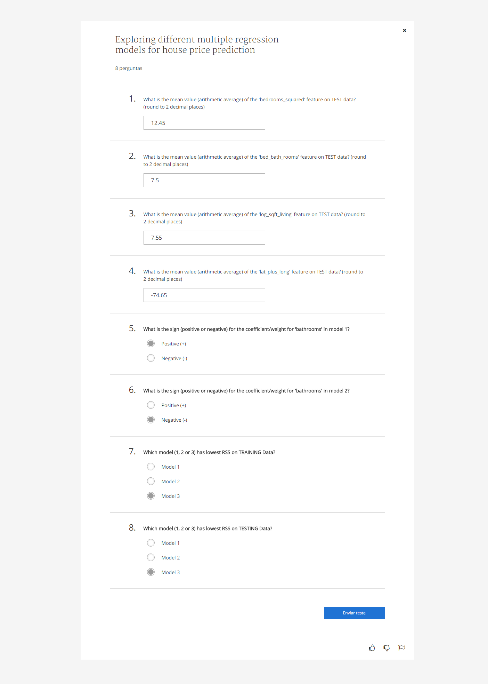

**Assignment 2:**

Quiz Question: What is the value of the weight for sqft_living -- the second element of ‘simple_weights’ (rounded to 1 decimal place)?

281.9 (281.91211912)

Quiz Question: What is the predicted price for the 1st house in the TEST data set for model 1 (round to nearest dollar)?

356134 (356134.44317093)

Quiz Question: What is the predicted price for the 1st house in the TEST data set for model 2 (round to nearest dollar)?

366651 (366651.41203656)

Quiz Question: Which estimate was closer to the true price for the 1st house on the Test data set, model 1 or model 2?

Model 1

Quiz Question: Which model (1 or 2) has lowest RSS on all of the TEST data?

Model 2